Contents

1. Introduction 1

2. Deployment Steps 1

I. Enable cluster not to run on ML Node. 2

II. Create a Model Group 3

III. Register the model MiniLM-L12 4

IV. Retrieve model_id 6

V. Deploy ML Model 7

VI. Retrieve ML model_id 7

VII. Retrieve ML model_id from Opensearch. 9

VIII. Test the ML model_id 10

IX. Create the Ingest pipeline using the ML model_id 11

X. Create the Search pipeline for Hybrid Query 12

# Introduction

We're utilizing a hybrid search approach, combining keyword and neural search techniques to enhance search relevance. A machine learning model is essential for processing the neural component of hybrid queries. Currently, we're leveraging pre-trained ML models provided by OpenSearch. After model creation, we establish an ingest pipeline to generate vector fields within the index. Additionally, we configure a search pipeline incorporating a normalization processor to allocate appropriate weights between keyword and neural search results.

# Deployment Steps

Below are the overall deployment steps for creating Machine learning Model.

* Enable cluster not to run on ML Node.
* Create a Model group
* Once model group is created copy the model_group_id. Use this model_group_id to register the model MiniLM-L12 .
* Once you register the model MiniLM-L12 a task initiated, copy the task_id and use this task_id to check the download/Registration status and get the model_id.
* Copy the model_id and use this model_id to deploy the ML model.
* Once you deploy the model a task initiated, copy the task_id and use this task_id to check the deploy status and get the ML model_id.
* Use the ML model to create the ingest pipeline.

## Enable cluster not to run on ML Node.

The recommended approach is to deploy the ML node on a dedicated node. Nevertheless, our current setup involves a single-node cluster, necessitating the use of the following command to ensure the cluster does not allocate resources to the ML node.

GET _cluster/settings

PUT _cluster/settings

{

"persistent": {

"plugins.ml_commons.only_run_on_ml_node": "false",

"plugins.ml_commons.model_access_control_enabled": "true",

"plugins.ml_commons.native_memory_threshold": "99"

}

}

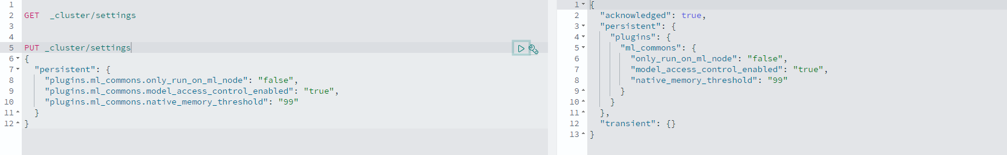

## Create a Model Group

We created a Model Group before implementing the ML model.

GET /_plugins/_ml/model_groups/_search

{

"query": {

"match_all": {}

},

"size": 1000

}

POST /_plugins/_ml/model_groups/_register

{

"name": "NLP_model_group",

"description": "A model group for NLP models"

}

{

"model_group_id": "GmujJ5EBNEzvN18lkEAb",

"status": "CREATED"

}

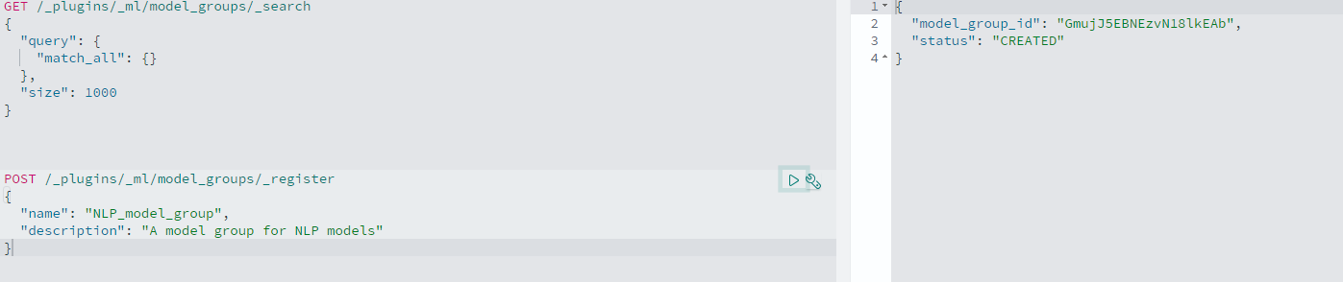

## Register the model MiniLM-L12

Once model group is created copy the model_group_id. Use this model_group_id to register the pre-trained ML model MiniLM-L12 provided by OpenSearch.

GET /_plugins/_ml/models/_search

{

"query": {

"match_all": {}

},

"size": 1000

}

POST /_plugins/_ml/models/_register

{

"name": "huggingface/sentence-transformers/all-MiniLM-L12-v2",

"version": "1.0.1",

"model_group_id": "GmujJ5EBNEzvN18lkEAb",

"model_format": "TORCH_SCRIPT"

}

{

"task_id": "G2uqJ5EBNEzvN18lW0Az",

"status": "CREATED"

}

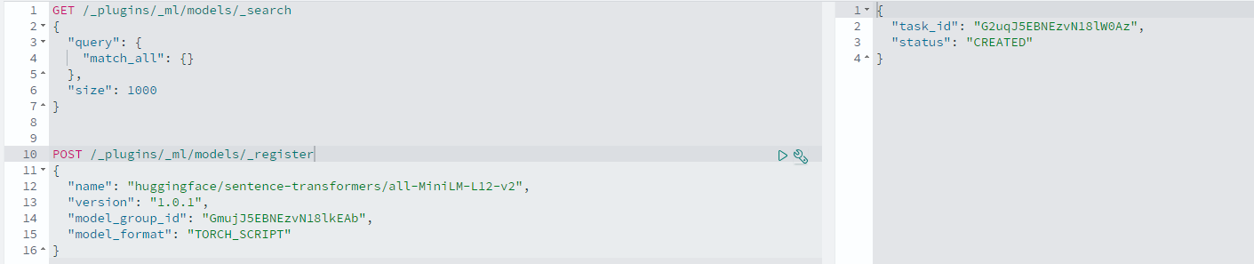

## Retrieve model_id

Once you register the model MiniLM-L12 a task initiated. Copy the task_id and use this task_id to check the download/Registration status and get the model_id.

GET /_plugins/_ml/tasks/G2uqJ5EBNEzvN18lW0Az

{

"model_id": "HGuqJ5EBNEzvN18lXkAX",

"task_type": "REGISTER_MODEL",

"function_name": "TEXT_EMBEDDING",

"state": "COMPLETED",

"worker_node": [

"fFgZGb0LQ0e3wziq_3iH4Q"

],

"create_time": 1722947361585,

"last_update_time": 1722947368530,

"is_async": true

}

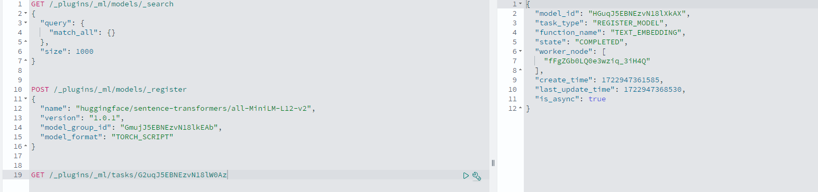

## Deploy ML Model

Copy the model_id and use this model_id to deploy the ML model.

POST /_plugins/_ml/models/HGuqJ5EBNEzvN18lXkAX/_deploy

{

"task_id": "HWvUJ5EBNEzvN18likDG",

"task_type": "DEPLOY_MODEL",

"status": "CREATED"

}

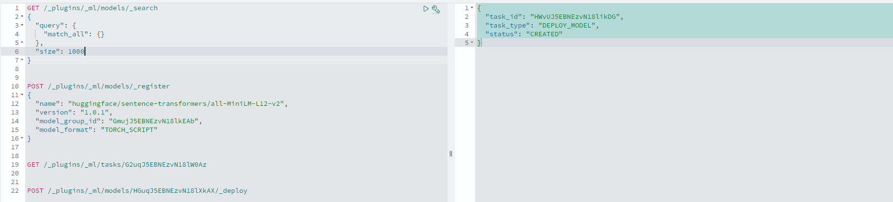

## Retrieve ML model_id

Once you deploy the model a task initiated, copy the task_id and use this task_id to check the deploy status and get the ML model_id.

GET /_plugins/_ml/tasks/HWvUJ5EBNEzvN18likDG

{

"model_id": "HGuqJ5EBNEzvN18lXkAX",

"task_type": "DEPLOY_MODEL",

"function_name": "TEXT_EMBEDDING",

"state": "COMPLETED",

"worker_node": [

"fFgZGb0LQ0e3wziq_3iH4Q"

],

"create_time": 1722950126278,

"last_update_time": 1722950131075,

"is_async": true

}

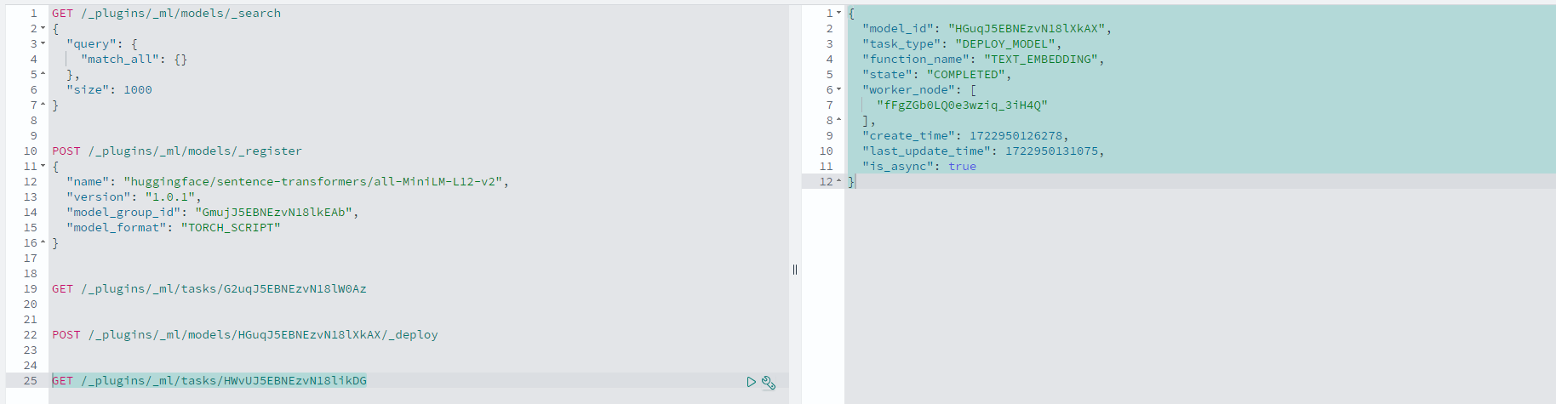

## Retrieve ML model_id from Opensearch.

We can retrieve the model_id from opensearch as well.

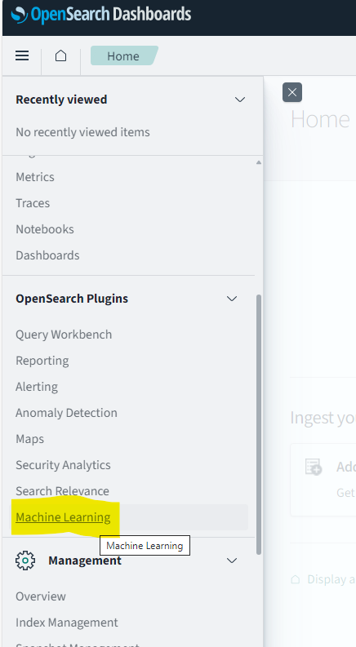

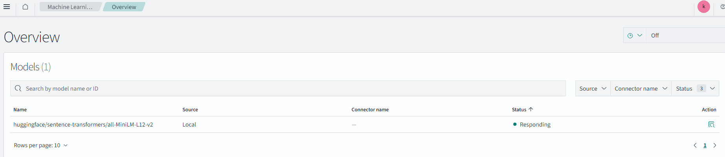

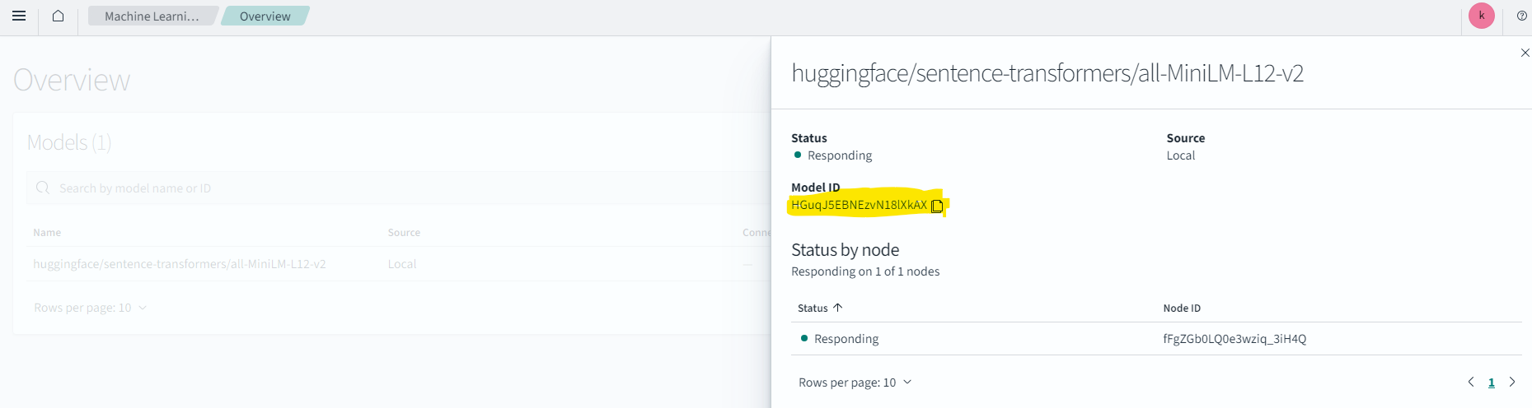

## Test the ML model_id

We can use below sample query to test our ML Model.

POST /_plugins/_ml/_predict/text_embedding/HGuqJ5EBNEzvN18lXkAX

{

"text_docs":[ "How to fix the printer issues"],

"return_number": true,

"target_response": ["sentence_embedding"]

}

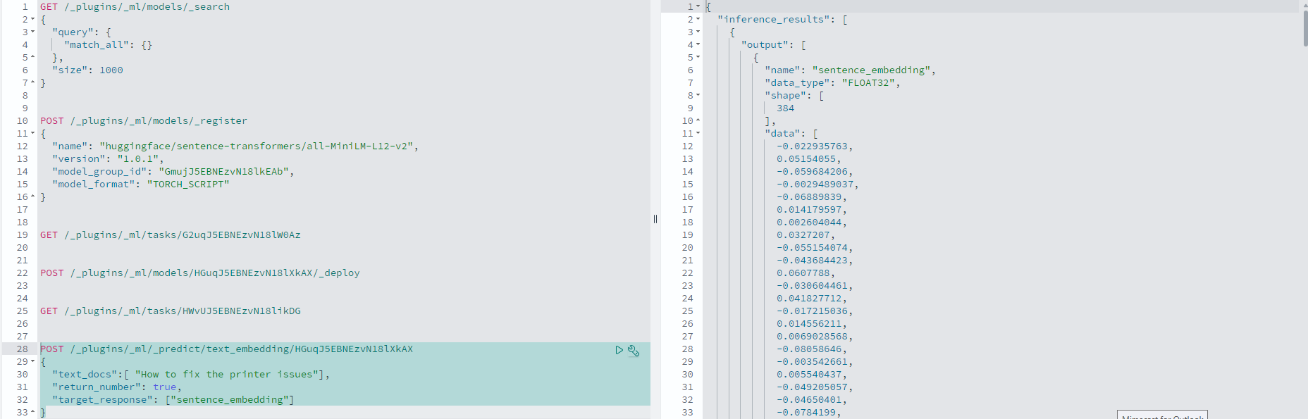

## Create the Ingest pipeline using the ML model_id

We can use the Model id to create an ingest pipeline to generate vector fields within the index.

PUT /_ingest/pipeline/doccebo.v2.emb_pipeline

{

"description": "A text embedding pipeline",

"processors": [

{

"text_embedding": {

"model_id": "HGuqJ5EBNEzvN18lXkAX",

"field_map": {

"ti_desc_prod": "query_embedding"

}

}

}

]

}

{

"acknowledged": true

}

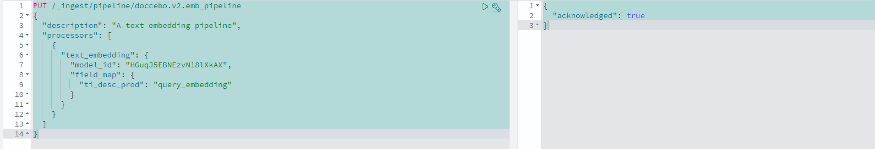

## Create the Search pipeline for Hybrid Query

We Should create a search pipeline to incorporate a normalization processor to allocate appropriate weights between keyword and neural search results in Hybrid Query.

PUT /_search/pipeline/nlp-hybrid-pipeline3

{

"description": "Post processor for hybrid search",

"phase_results_processors": [

{

"normalization-processor": {

"normalization": {

"technique": "min_max"

},

"combination": {

"technique": "arithmetic_mean",

"parameters": {

"weights": [

0.7,

0.3

]

}

}

}

}

]

}

{

"acknowledged": true

}

